Ordering an Original Copy of Your Solo

For your recital/contest solo, you must have ordered an original copy of your solo by this Friday, December 13th.
*The original copy that you order online or from Griggs music will contain: 1) a copy of the solo part and 2) a copy of the piano part (has the solo part on it as well).

There are two reasons for this.

- For copyright purposes, the judge must receive an original copy (purchased copy from the publisher, usually printed on thicker paper) of the solo part. If they do not, the solo/ensemble organization must lower your final rating by one level.
- The piano part must be given to your accompanist by January 15th. If you get a copy of the piano part to Mr. Hernandez before Christmas break, he will deliver it to your accompanist for you.

How to order an original copy:

- Google the name of the piece/composer/instrument/solo.
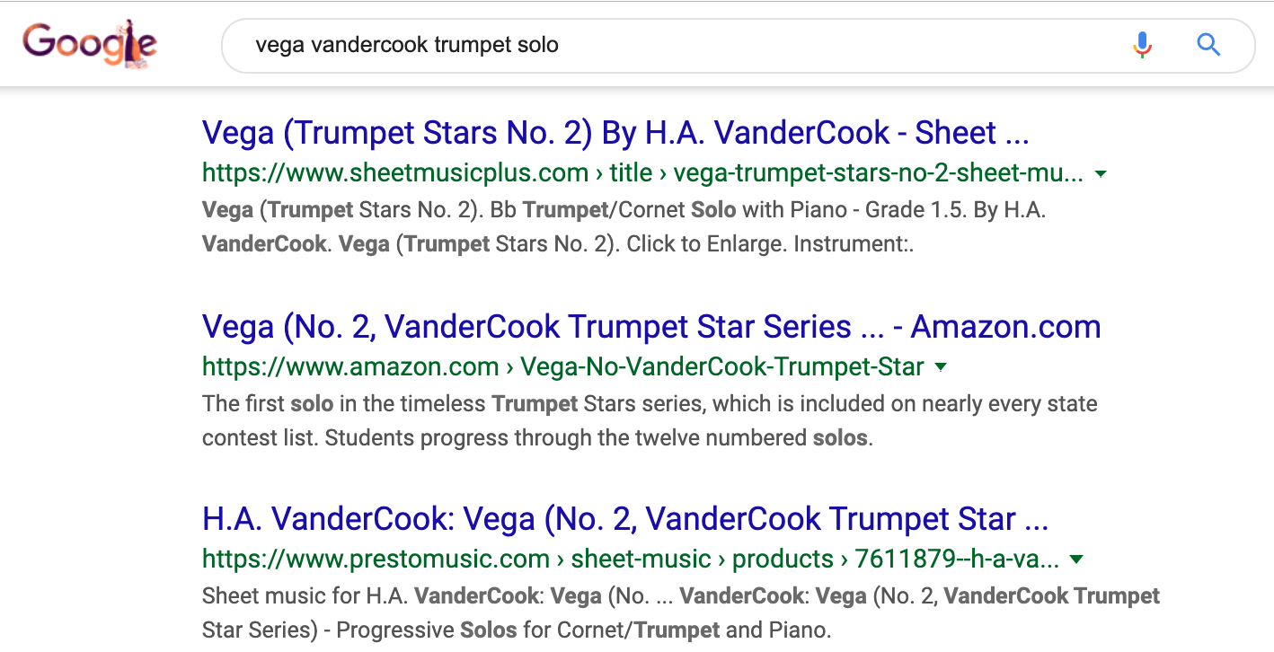

If this does not give you the proper result, add the publisher in your google search. Sites that are usually pretty reliable to purchase music from include but are not limited to: jwpepper.com, amazon.com, grothmusic.com, stantons.com.
- You could also contact Griggs music and order any solo from them. Be prepared to tell them the following information: 1) piece title 2) composer 3) publisher. This information can be found on the 1st page of your solo (details on back of this page).

If you find one online that is not from one of these sites, and would like to check with me to verify that it is a reliable source, feel free to email me (ahernandez@geneseoschools.org) with a link to double check.
